Type of product:

Stadia can be classified as an **augmented service** as the main purchasable is a subscription-based service that can’t be access without a sufficiently high internet speed connection (a minimum of **10Mbps** according to their website[1]) so it can’t be a product as a product must be tangible and can be consumed at will without a special requirement(internet connection).

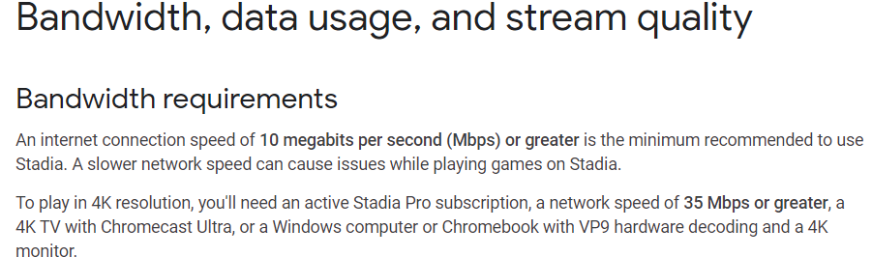

Figure : screen capture of internet requirement

As for the augmented part, Stadia subscriptions include (optional) products to use with the service such as the stadia controller

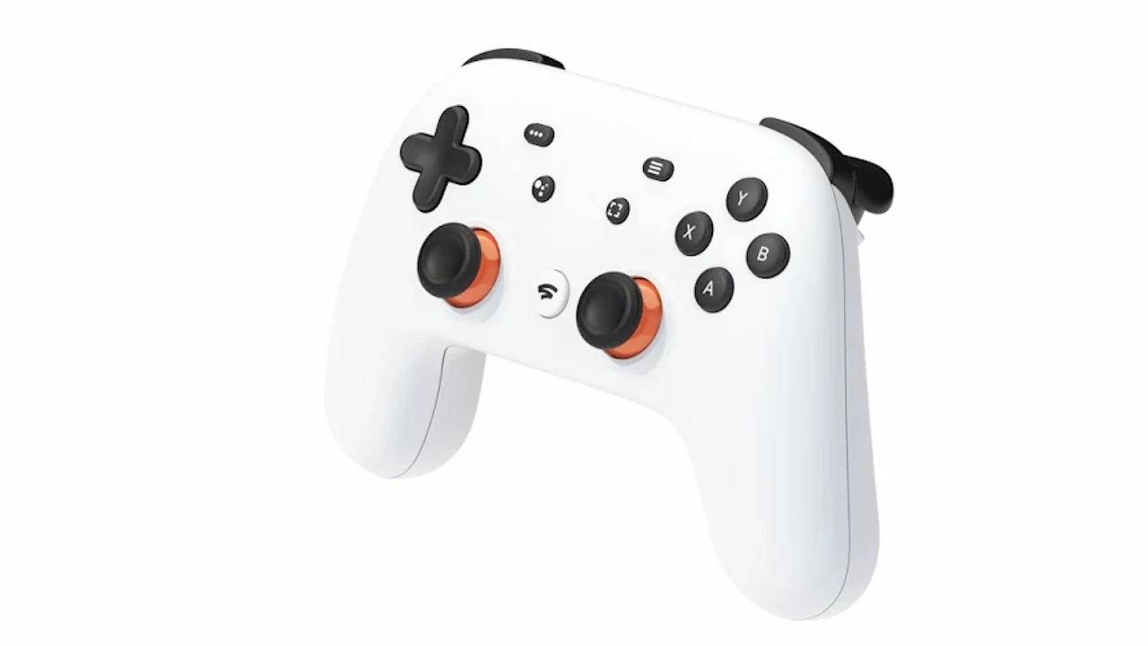

Figure : google stadia controller

In conclusion, google stadia is a **service** with **optional products** to enhance the experience

References:

[1]: <https://support.google.com/stadia/answer/9607891?hl=en>